*EXCEL SPREADSHEET ASSIGNMENT-1*

*QUES-1. What do you mean by cells in an excel sheet?*

*ANS-1 Cell: A cell is****a rectangular area formed by the intersection of a column and a row****.  For example the cell in Column "C" in Row "3" would be cell C3.*

*QUES 2. how can you restrict someone from copying a cell from your worksheet?*

*ANS-2 In order to protect your worksheet from getting copied, you need to go into****Menu bar >Review > Protect sheet > Password****. By entering password, you can secure your worksheet from getting copied by others.*

*QUES 3. how to move or copy the worksheet into another workbook?*

*ANS-3* ***Move a sheet to another workbook***

1. *Open the workbook that you want to move the sheet to.*
2. *On the Window menu, click the workbook that contains the sheet that you want to move. ...*
3. *On the Edit menu, click Sheet > Move or Copy Sheet.*
4. *On the To book menu, click the workbook that you want to move the sheet to.*

*Copy a worksheet in the same workbook*

*1.Press CTRL and drag the worksheet tab to the tab location you want.*

*QUES 4. which key is used as a shortcut for opening a new window document?*

*ANS-4 CTRL+O*

*QUES 5. What are the things that we can notice after opening the Excel interface?*

***ANS-5 The Excel window***

* *Title bar. The title bar displays both the name of the application and the name of the spreadsheet.*
* *Menu bar. The menu bar displays all of the menus available for use in Excel XP. ...*
* *Column headings. ...*
* *Row headings. ...*
* *Name box. ...*
* *Formula bar. ...*
* *Cell. ...*
* *Navigation buttons and sheet tabs.*

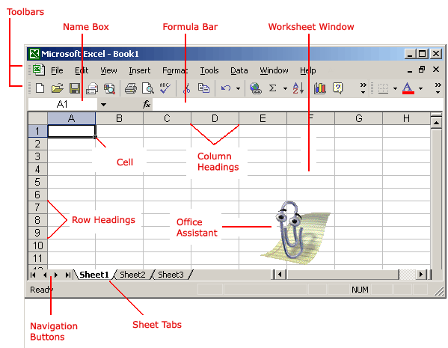

*QUES 6. When to use a relative cell reference in excel?*

*ANS- 6  Relative references are especially convenient****whenever you need to repeat the same calculation across multiple rows or columns****.*

